BIRCHOVER WALK

THE WALK
This very enjoyable and rewarding walk only requires the minimum of effort yet still manages to provide a rich diversity of scenery. At the start of the walk, there are views over the rooftops of the houses in Birchover, leading to the isolated, bracken covered gritstone plateau of Stanton Moor, and then the magnificent views across the surrounding countryside as you walk round the edge of the moor.

Stanton Moor attracts considerable interest because of the remarkable amount of prehistoric remains that have been found. Last century, the Heathcote family of Birchover, excavated in excess of 70 burial mounds on the moor.
The most famous of the Bronze Age relics on the moor are The Nine Ladies Stone Circle. Legend has it that the nine ladies danced here on the Sabbath Day and were turned to stone as a punishment, along with the fiddler who stands nearby.
A construction of more recent vintage, on the edge of the moor, is the Earl Grey Tower, which commemorates the passing of the Reform Bill in 1832 and was erected by the Thornhill family of Stanton-in-Peak.
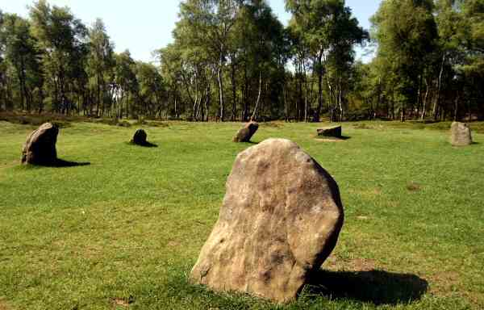
WALK DETAILS
Length: 3 miles.
Start/finish: Main Street close to Red Lion.
Location: Off B5056 a linking road between Ashbourne and Bakewell.
Terrain: Easy walking, for the most part on good tracks round Stanton Moor. No steep gradients.

THE ROUTE
1. Walk down the road towards the Druid Inn and, as the road bends to the right opposite the Inn, turn sharp right up a tree-lined path, climbing up above the village houses.
2. On passing through a quarry car park, turn left and walk along the road towards Stanton for a quarter of a mile, before turning right onto a footpath with a walled entrance.

3. Continue up a rough track for a short distance to enter Stanton Moor by a high stile and continue straight ahead to reach the Cork Stone. A large upright stone with climbing footholds and handgrips added.

4. At this point as the path forks, keep to the right, and then at a path crossroads further along the moor go left for half a mile to reach The Nine Ladies Stone Circle.

5. Turn to the right from the Stone Circle and gradually descend through the trees, going to the left at a fork in the path and walk towards Earl Grey’s Tower.

6. Cross the stile by the tower and descend the steps on the other side, turn right along the path round the edge of the moor, keeping close to the fence.

7. After about three quarters of a mile, the path descends to a minor road.

8. Here you turn right for about 200 yards and then go through a stile on the left and follow the path round the side of a hill towards Barn Farm.

9. Keep to the rear of the farm buildings, heading towards the bottom right hand corner of the field to go through a stile by a gate where you immediately turn right.

10. Continue straight ahead, shortly to join the farm drive that leads to the road back into Birchover, where you turn left to return to the start of the walk.
